**Step 1: Create Three Virtual Machines**

1. **Log into Azure Portal**:
   * Go to the [Azure Portal](https://portal.azure.com/) and sign in.
2. **Create a Resource Group (if needed)**:
   * Click on **Resource groups** in the left-hand menu.
   * Click **+ Create**.
   * Fill in the required details (name, region) and click **Review + Create**, then **Create**.
3. **Create the Virtual Machines**:
   * Click on **Create a resource** > **Compute** > **Virtual Machine**.
   * Fill in the required details for each VM (you’ll do this three times):
     + **Subscription**: Choose your subscription.
     + **Resource Group**: Select the resource group you created or an existing one.
     + **Virtual Machine Name**: Give each VM a unique name (e.g., VM1, VM2).
     + **Region**: Choose the same region for all VMs for better performance.
     + **Image**: Select an operating system (e.g., Ubuntu Server).
     + **Size**: Select an appropriate size for the VM.
     + **Authentication Type**: Choose between SSH public key or password for authentication.
     + **Networking**:
       - Create or select a Virtual Network and Subnet.
       - Ensure the VMs are set to use the same virtual network.
   * **Review + Create** and then click **Create** to deploy each VM.

**Step 2: Set Up Load Balancing**

1. **Create a Load Balancer**:
   * In the Azure Portal, search for **Load Balancers** and click **Create**.
   * Fill in the required details:
     + **Name**: Give your load balancer a name (e.g., MyLoadBalancer).
     + **Region**: Select the same region as your VMs.
     + **SKU**: Choose between Standard or Basic depending on your requirements.
     + **Resource Group**: Select the same resource group as your VMs.
   * Click **Review + Create**, then click **Create**.
2. **Configure Load Balancer**:
   * After the load balancer is created, navigate to its settings.
   * Click on **Frontend IP configuration** > **Add frontend IP configuration**.
     + **Name**: Give it a name (e.g., FrontendIP).
     + **Public IP address**: Create a new public IP address.
   * Click **Save**.
3. **Set Up Backend Pool**:
   * Go to **Backend pools** > **Add**.
     + **Name**: Give it a name (e.g., BackendPool).
     + **Virtual machines**: Add the VMs to this pool.
   * Click **Add** to save the configuration.
4. **Create Load Balancer Rules**:
   * Go to **Load balancing rules** > **Add**.
     + **Name**: Give it a name (e.g., lbRule).
     + **Frontend IP address**: Select the frontend IP configuration you created.
     + **Backend port**: Set to the port your application listens to (e.g., 80 for HTTP).
     + **Frontend port**: Set to the same value as the backend port.
     + **Protocol**: Select TCP.
     + **Session persistence**: Choose as per your requirement (None or Client IP).
   * Click **Add** to save the rule.

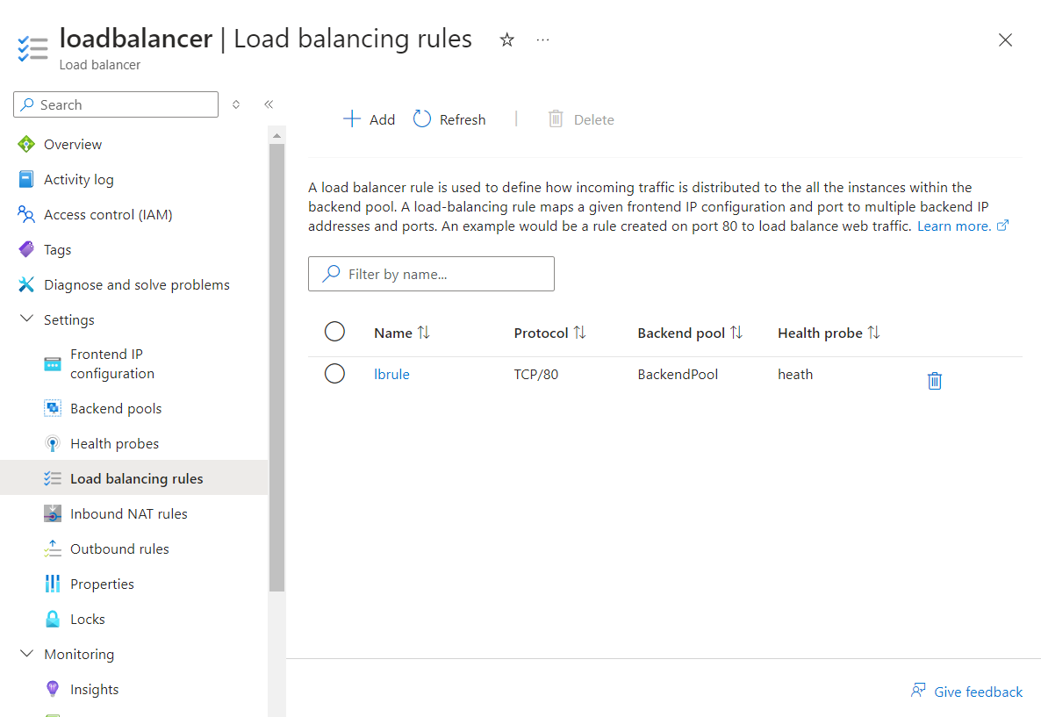

**Step 3: Set Up Azure Monitor for Alerts**

**1. Enable Network Watcher:**

1. In the Azure Portal, search for **Network Watcher**.
2. Under **Network Watcher Settings**, select **Regions** and make sure the region where your VMs are deployed is enabled.

**2. Create a Connection Monitor:**

1. In **Network Watcher**, go to **Connection Monitor** and click on **+ Create**.
2. Set a **Name** for the monitor and select the **Resource Group** and **Region**.
3. In the **Source and Destination** section:
   * Set **VM1** as the source and **VM2** as the destination.
4. Click **Add Test** and **Create** the connection monitor.

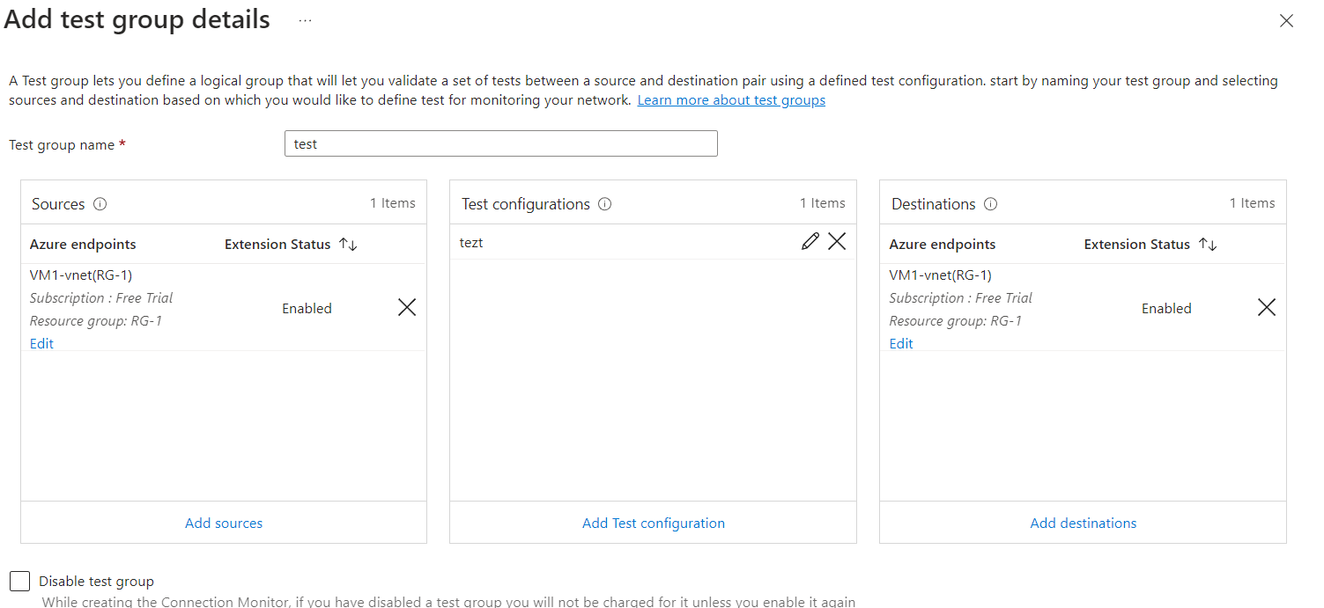

**3. Create an Alert:**

1. In the Azure Portal, search for **Monitor** and go to the **Alerts** section.
2. Click **+ New alert rule**.
3. In the **Resource** section, select the **Connection Monitor** created in the previous step.
4. In **Condition**, click on **Add Condition** and select the **Round Trip Time** metric.
   * Set the condition to trigger when the average RTT exceeds **100 ms**.
5. Under **Actions**, create an **Action Group** with an email or SMS notification.

**4. Configure the Action Group:**

1. When creating an alert rule, in the **Actions** section, click **Create New Action Group**.
2. Provide the **Action Group** details, and under **Notifications**, choose **Email/SMS/Push/Voice**.
3. **Save** and attach this action group to the alert.

